EXPT NO:3 | CLEANSE DATA BY HANDLING MISSING VALUES, OUTLIERS, AND INCONSISTENCIES USING TABLEAU AND POWERBI
DATE: 10.07.2026

PRE-LAB QUESTIONS (PROVIDE BRIEF ANSWERS TO THE FOLLOWING QUESTIONS)
- What are the potential impacts of missing values in a dataset, and what are some common strategies to address them in Tableau and Power BI?

Missing values can reduce data accuracy and affect analysis results. They can be handled by removing records, replacing them with suitable values, or using calculated fields such as IFNULL in Tableau and Power Query transformations in Power BI.

- What is the importance of identifying and addressing outliers in a dataset? How can outliers affect data analysis and model performance?

Outliers can distort statistical measures and lead to misleading conclusions. They may affect averages, trends, and model performance, so they should be investigated, flagged, filtered, or handled appropriately.

- What types of data inconsistencies might you encounter during data cleansing, and how can Tableau and Power BI help in resolving them?

Common inconsistencies include different spellings, capitalization, date formats, units, and duplicate records. Tableau provides Group, Alias, and calculated fields, while Power BI provides Replace Values, formatting tools, and Power Query transformations.

- How do you identify patterns in data using visualizations to spot missing values, outliers, and inconsistencies?

Charts such as bar charts, scatter plots, histograms, and box plots help reveal unusual values, gaps, and inconsistent patterns in the data.
- What is the role of calculated fields in data cleansing, and how can they be used to handle missing values and outliers in Tableau/Power BI?

Calculated fields create new cleaned or flagged values without changing the original data. They can replace missing values, standardize data, and identify outliers using conditional logic.

IN-LAB EXERCISE:
OBJECTIVE:
To clean a given dataset (e.g., Superstore Sample in Tableau and Financials/Sales Data in Power BI) by identifying and resolving missing values, outliers, and inconsistencies using built-in tools, ensuring the dataset is accurate and ready for analysis.

PROCEDURE:

Open the Tool and Connect Dataset
    - Open Tableau Desktop , Power BI Desktop.
    - Load the built-in dataset (Sample - Superstore in Tableau / Financials in Power BI).
    - Preview the dataset to understand its structure.

Initial Inspection
    - Explore fields such as Sales, Profit, Region, or Product Category.
    - Check for nulls, inconsistent text values (e.g., "South Region" vs. "South"), or date formatting issues.

Handling Missing Values
    - Use Data Interpreter (Tableau) / Power Query (Power BI) to highlight nulls.
    - Replace missing numerical values with mean/median, and text with "Unknown".
    - Use calculated fields: IFNULL([Field], Default) in Tableau or IF(ISBLANK([Field]), "Unknown", [Field]) in Power BI.

Detecting and Managing Outliers
    - Create scatter or box plots for Sales and Profit to identify extreme values.
    - Choose strategies:
      - Filter them temporarily.
      - Apply caps using calculated columns.

      - Flag them with labels for review.

Resolving Inconsistencies
    - Use Group/Alias (Tableau) / Replace Values (Power BI) to standardize text.
    - Normalize data formats, such as date fields or currency units.

Validation with Visuals
    - Build dashboards with histograms, bar charts, and box plots to visually confirm improvements.
    - Compare before/after cleaning stages for accuracy.

Save the Cleaned Dataset
    - Save as .twbx (Tableau) / .pbix (Power BI).
    - Optionally export cleaned data to .csv.

Summary Dashboard
    - Create a visual summary of the cleaning process, highlighting:
      - Fields corrected.
      - Nulls/outliers removed or adjusted.
      - Clean dataset metrics (record count, completeness %).

Experiment Dataset:
- Tableau: Sample - Superstore
- Power BI: Financials or Sales Data

How to Access:
Tableau:
  - Navigate to: Start Page → Sample Workbooks
  - Or: Help → Sample Data → Open Sample Data Folder

Power BI:
  - Navigate to: Home → Get Data → Excel → Choose sample datasets (e.g., Financial Sample.xlsx)
  - Microsoft also hosts Power BI sample datasets online.

Fields Used:
- Sales
- Profit
- Region
- Category

- Order Date / Transaction Date
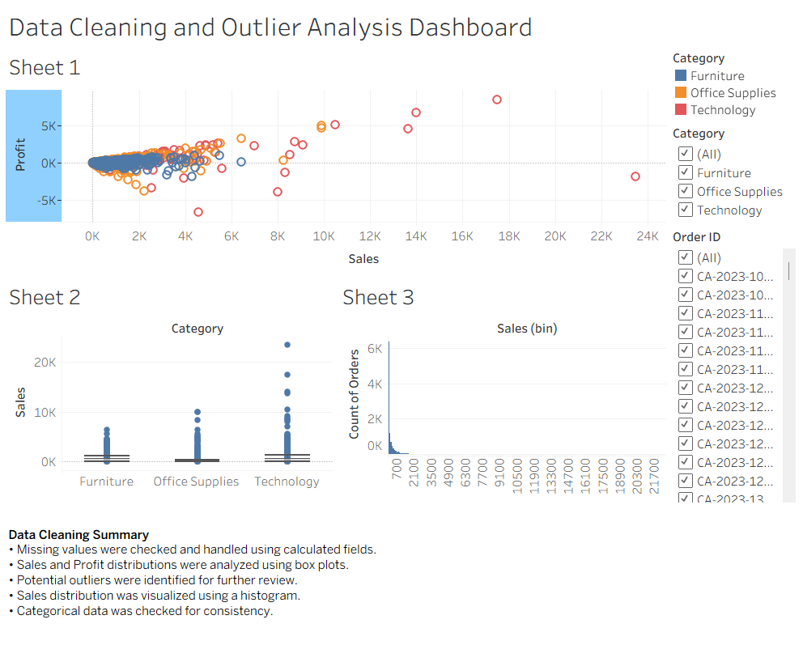
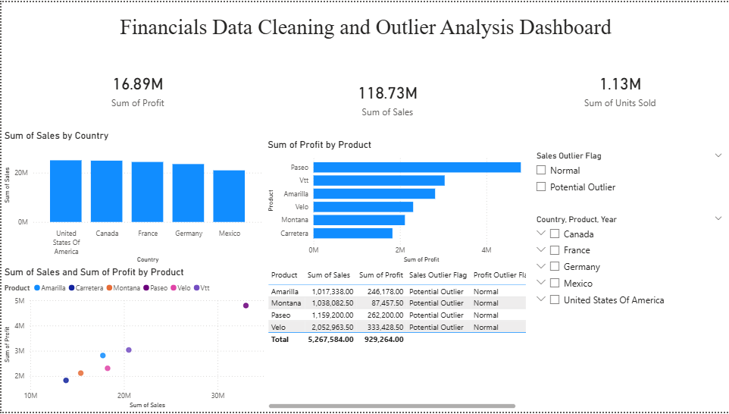

POST-LAB QUESTIONS (PROVIDE BRIEF ANSWERS TO THE FOLLOWING QUESTIONS)
- What method did you use to replace missing values in numeric fields?

Missing numeric values were replaced with 0 using calculated fields such as IFNULL in Tableau and conditional columns in Power BI.

- How were outliers handled in your dataset and what visual confirmed their correction?

Outliers were identified and flagged for review rather than immediately deleted. Box plots and scatter plots were used to confirm unusual values.

- What inconsistencies were detected in categorical values and how were they standardized?

Inconsistent text values, such as different spellings or capitalization, were standardized using Group/Alias in Tableau and Replace Values/Format tools in Power BI.

- Describe how calculated fields helped in resolving data issues.

Calculated fields helped replace missing values, create cleaned fields, standardize categories, and flag potential outliers using conditional logic.

- How did your dashboard demonstrate the effectiveness of the data cleaning process?

The dashboard displayed cleaned data through charts, box plots, scatter plots, and summary metrics, allowing comparison and visual validation of the dataset after cleaning.

RESULT:

The dataset was successfully cleaned and prepared for accurate analysis using Tableau and Power BI. Issues such as nulls, inconsistencies, and outliers were identified and resolved, improving data quality significantly.

Github Repo - > https://github.com/Pavann-07/24ADC001---24BAD085.git

ASSESSMENT

Description | Max Marks | Marks Awarded
Pre Lab Exercise | 5
In Lab Exercise | 10
Post Lab Exercise | 5
Viva | 10
Total | 30
Faculty Signature

